**NAME :**AFSAN HAQUE

**ID :**20301145

1. **Ans:**Almost every application available in google is on cloud . Some applications are hosted in some platforms like Heroku, Digitalocean etc. Some pages are also hosted in Github. But those applications which have higher amount of traffics needs to be on cloud to fulfill the requirements of the customers. So there are rarely any cloud computing applications that are not on google

**2)Ans : Some basic linux commands are :**

**1) mkdir [directory name to be created]**

This command creates a new directory.

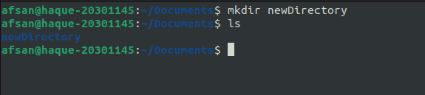

**2) cd [directory name]**

It changes the directory

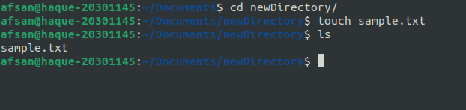

**3) vi, cat [file name]**

Cat opens a file and vim opens and enables to edit

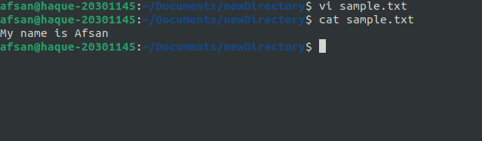

**4) cd ..**

Go to previous directory

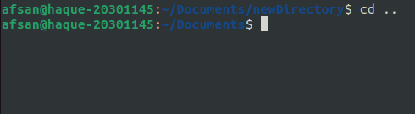

**5) ifconfig**

Shows network addresses

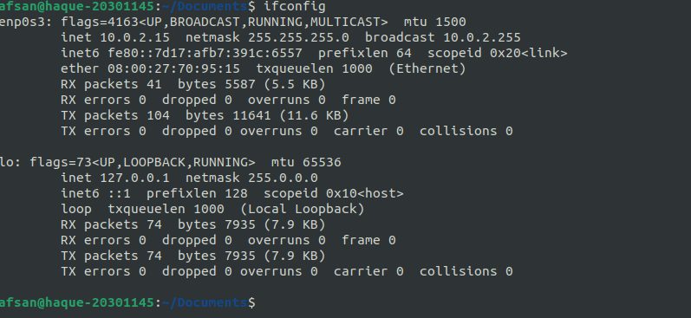

**6) ls [directory name]**

Lists all the files,directories

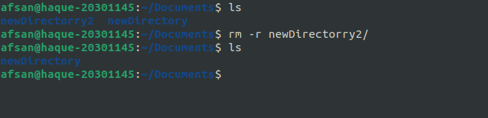

**7) rm [file name]**

Removes a file

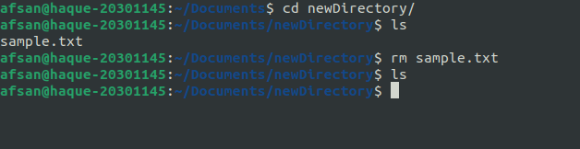

**8) cp [copied file name] [path to put the file]**

Copy the file from a source to destination

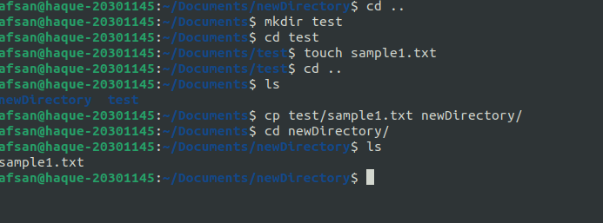

**9) ls -la**

Show all the files with accesibilities

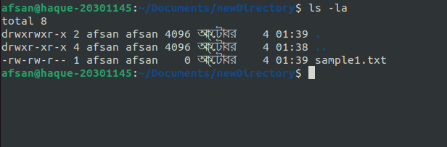

**10) mv [from] [to]**

Move or cuts the file

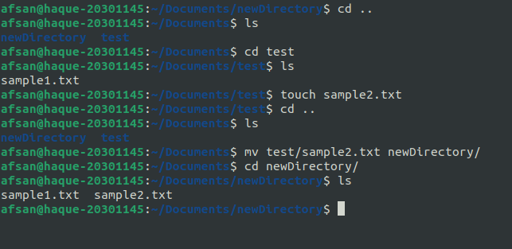

**11) history**

Check the command history

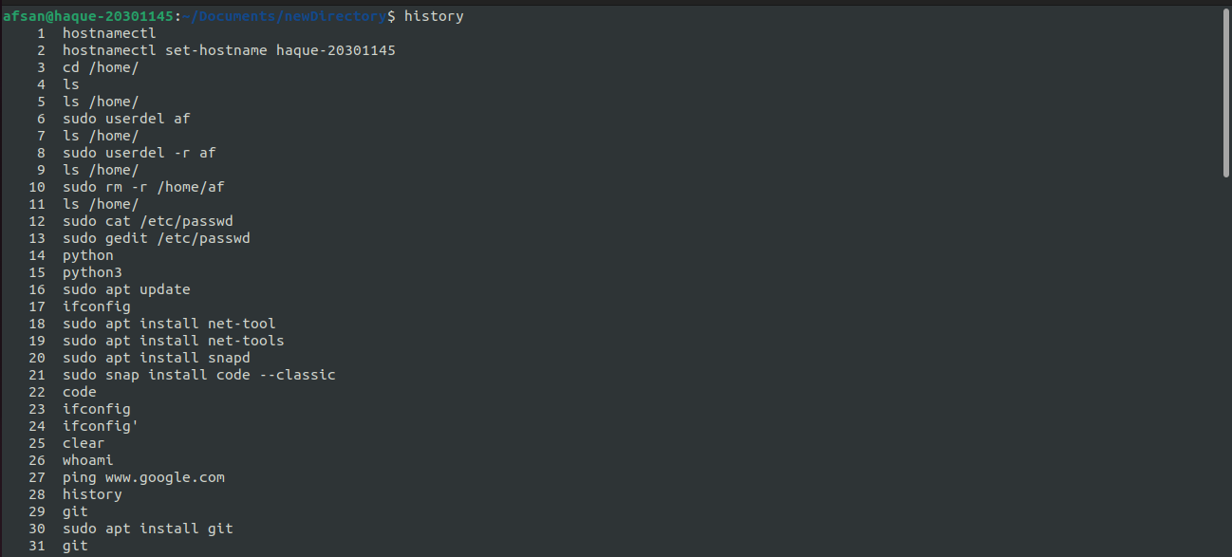

**11) man [command name]**

Show all the functionalities of a command

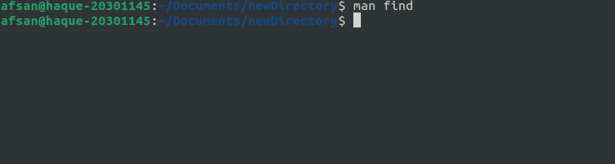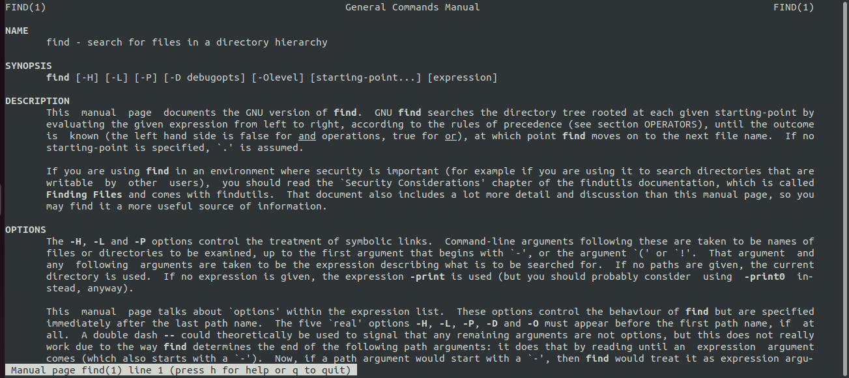

**12) find -type file**

Find file types

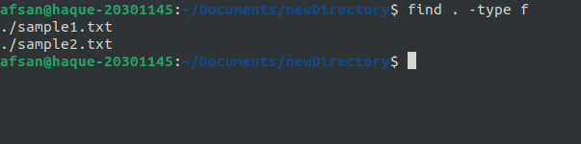

**13) find -type d**

Find Directory types

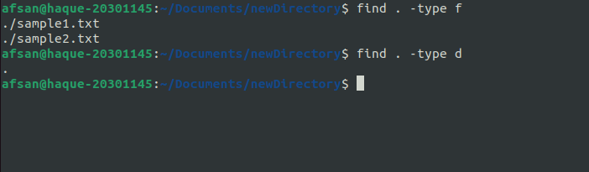

**14) find -name**

Find a file with a name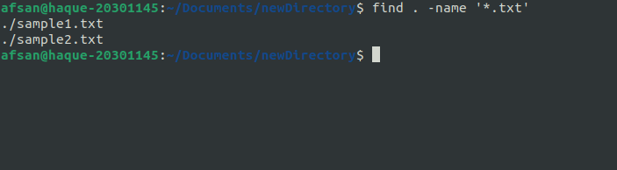

**15) su [ username ]**

Change from user to root

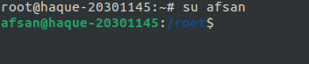

**16)whoami**

Shows username

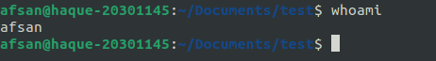

**17) sudo -i**

Change to root from user

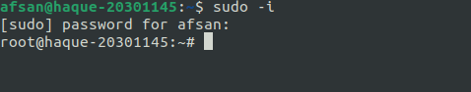

**18) grep -i [pattern] [file name]**

Find a patter in a file

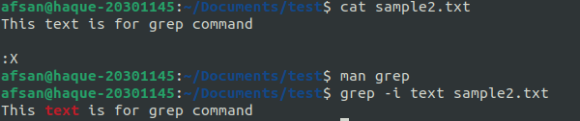

**19) hostnamectl**

Shows all the userid,names

